UML-diagrams

Use-case-diagram

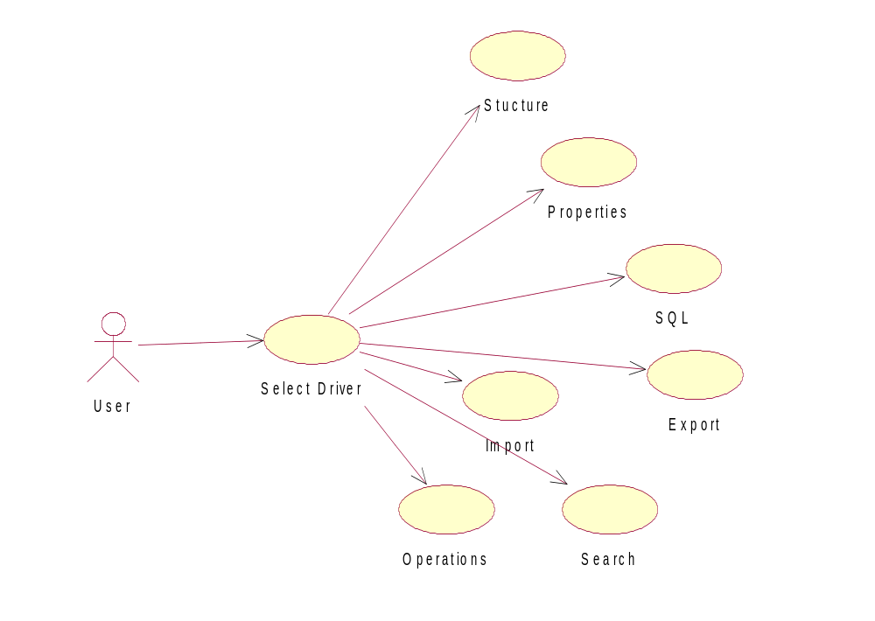

Sequential-diagram

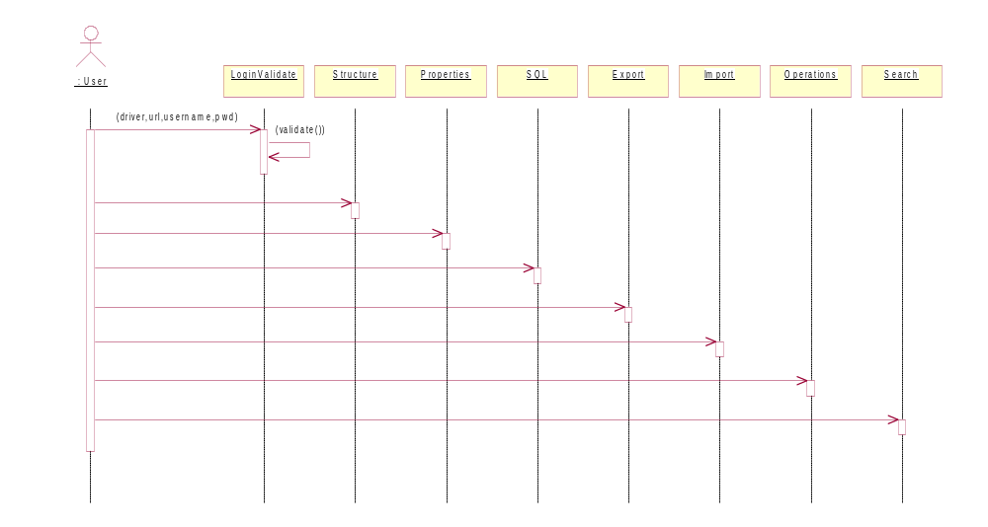

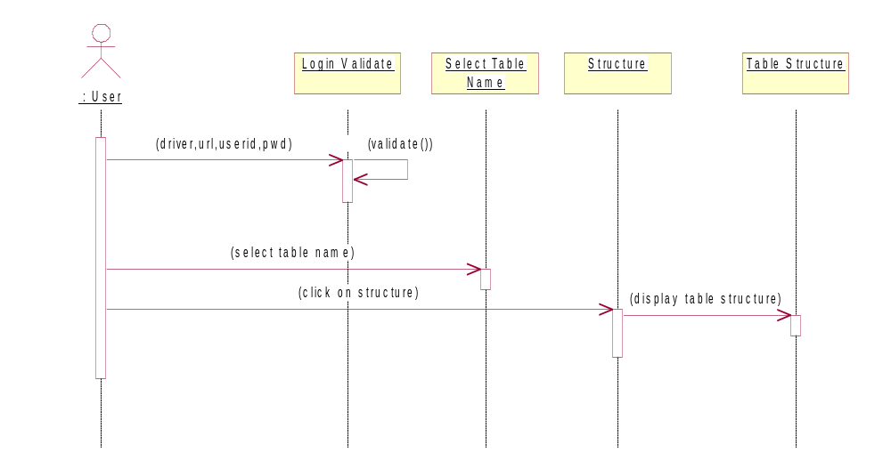

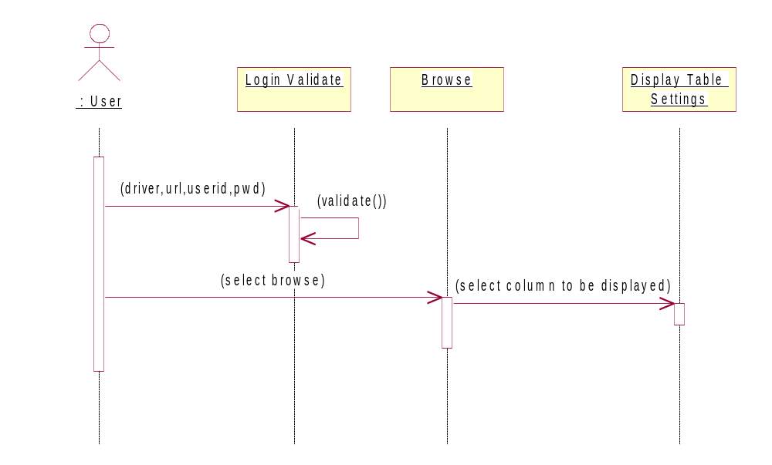

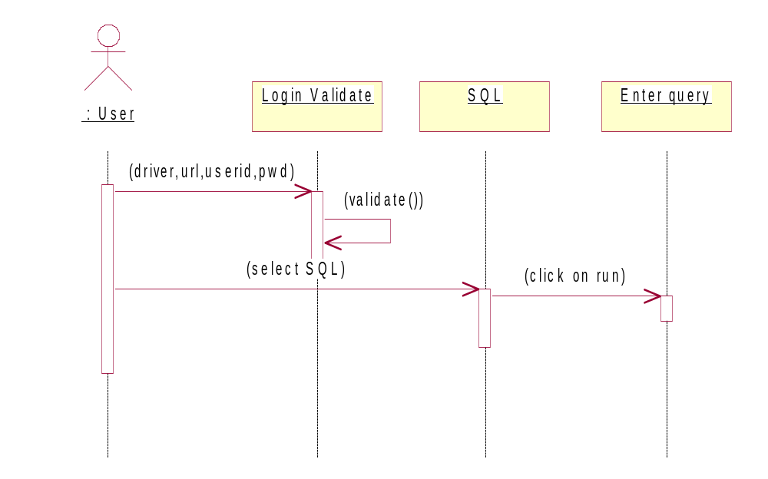

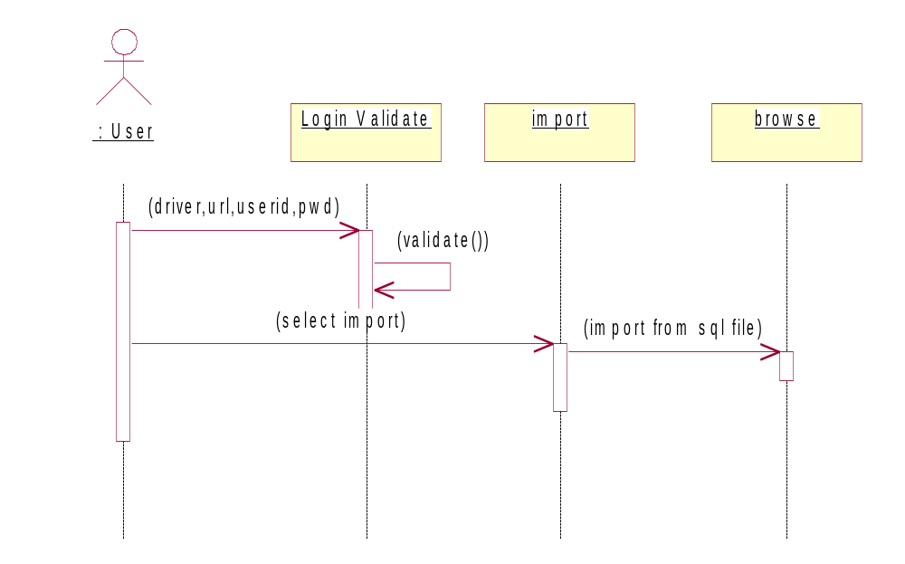
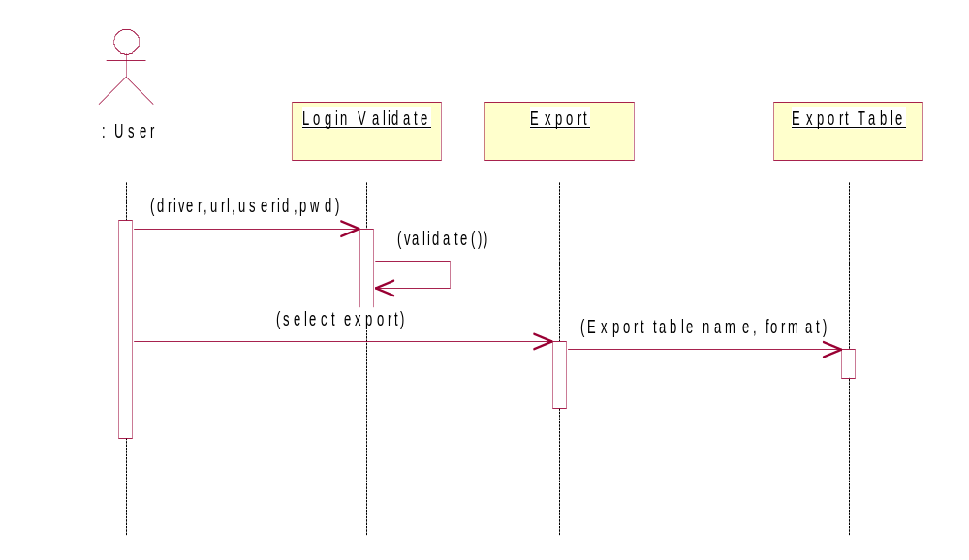

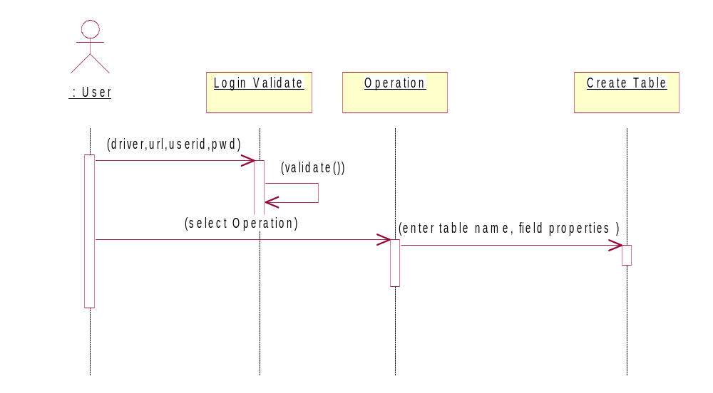

Search
Database
: User
Login Validate
Search
(driver,url,userid,pwd)
(validate())
(select search)
(enter keyword,select search options)

Class –diagram
DataManipulator
Edit Form
Create Tab
Renametab
InputScreen
Report
Menu
GUIComponent
Empty column
DataStore
Desc tab

Browse Form

List DB

<<instantiates>>
<<uses>>
Options
DBOperations

State-diagram

unauthenticated
validation
authenticated
( id,pwd )
( ok )
( id,pwd )

Activity Diagram

unauthenticated
Validation
DB Menu
( Driver,username,pwd)
( invalid )
( valid )

Collabration Diagram

: USER
login
authenti
cation
OPERATION
Query
: USER
UPDATE
1: logs in
2:
3:
4: results
5: results
8: instruction
6: instructs
7:

Realization Diagram

<<Class>>
Login

+ void: doGet (req, res)
+printwiter: Close ()
<<Class>>
<<LOAD ALL>>

+ void: doPost (req, res)
+printwiter: Close ()

Participating Classes

Login

Import
Export

SearchDB
DBProperties
Tab Operations
Logout
DescDB
InsertFom

